***SAMEER SHAHZAD BSSE-23025  
HANNAN SHAHZAD BSSE-23055***

**Technical Report: AWS-Based Car Parking Information Management System**

**Table of Contents**

1. Executive Summary
2. Introduction
3. Problem Statement
4. Aim and Objectives
5. AWS Architecture & Implementation Steps
   * 5.1 AWS Instance Setup
   * 5.2 IAM Roles & Security Groups
   * 5.3 Deployment & Nginx Configuration
6. Testing and Results
7. Monitoring & Logging
8. Conclusion
9. References

**1. Executive Summary**

This report presents the deployment of a **Car Parking Information Management System** on the Amazon Web Services (AWS) cloud platform. The solution leverages AWS EC2 for scalable computing, Nginx as a reverse proxy, and a Django-based backend. The implementation ensures high availability, security through AWS Security Groups, and efficient traffic management. The final outcome is a fully functional web application accessible via a public IPv4 address.

**2. Introduction**

In the modern era, managing parking spaces manually is inefficient and prone to errors. This project utilizes cloud computing to provide a centralized system for tracking vehicle entries, exits, and slot availability. By using AWS, we ensure that the system is accessible from anywhere, providing a robust infrastructure for urban parking management.

**3. Problem Statement**

Traditional parking systems suffer from:

* Lack of real-time data on available slots.
* Manual record-keeping leading to data loss.
* Limited accessibility for administrators. **Solution:** A cloud-hosted Django application that automates the process and provides an instant dashboard for parking management.

**4. Aim and Objectives**

* **Aim:** To deploy a secure and scalable parking management system on AWS.
* **Objectives:**
  + Configure an AWS EC2 instance with Ubuntu 24.04.
  + Implement Nginx as a reverse proxy for the Django application.
  + Ensure system security using AWS Security Groups (Port 80, 8000, 22).
  + Automate the server process using Gunicorn or Nohup.

**5. AWS Architecture & Implementation Steps**

**5.1 AWS Instance Setup**

1. Log in to AWS Console and navigate to EC2.
2. Launch a t2.micro instance using the Ubuntu 24.04 AMI.
3. Download the .pem key pair for SSH access.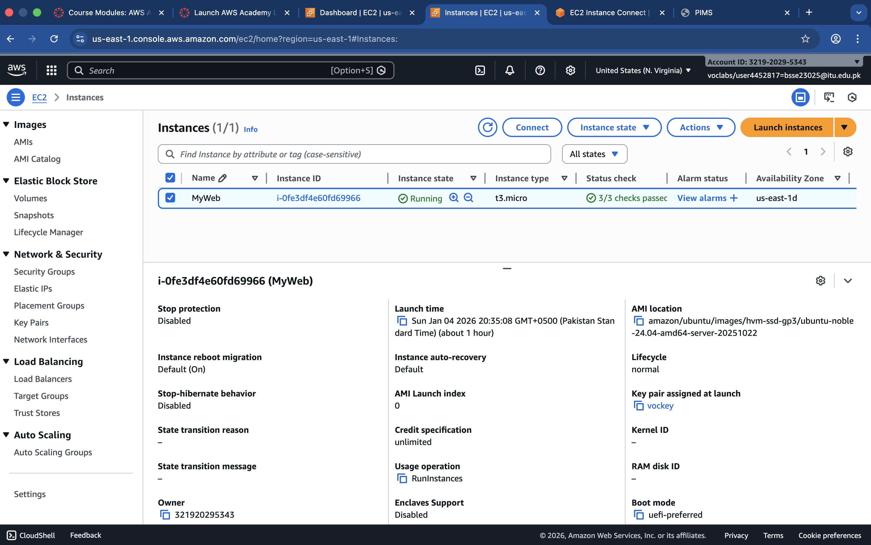

**5.2 IAM Roles & Security Groups**

To allow web traffic, we configured the following Inbound Rules:

* **SSH (22):** For remote terminal access.
* **HTTP (80):** For public web access via Nginx.
* **Custom TCP (8000):** For direct Django backend testing.

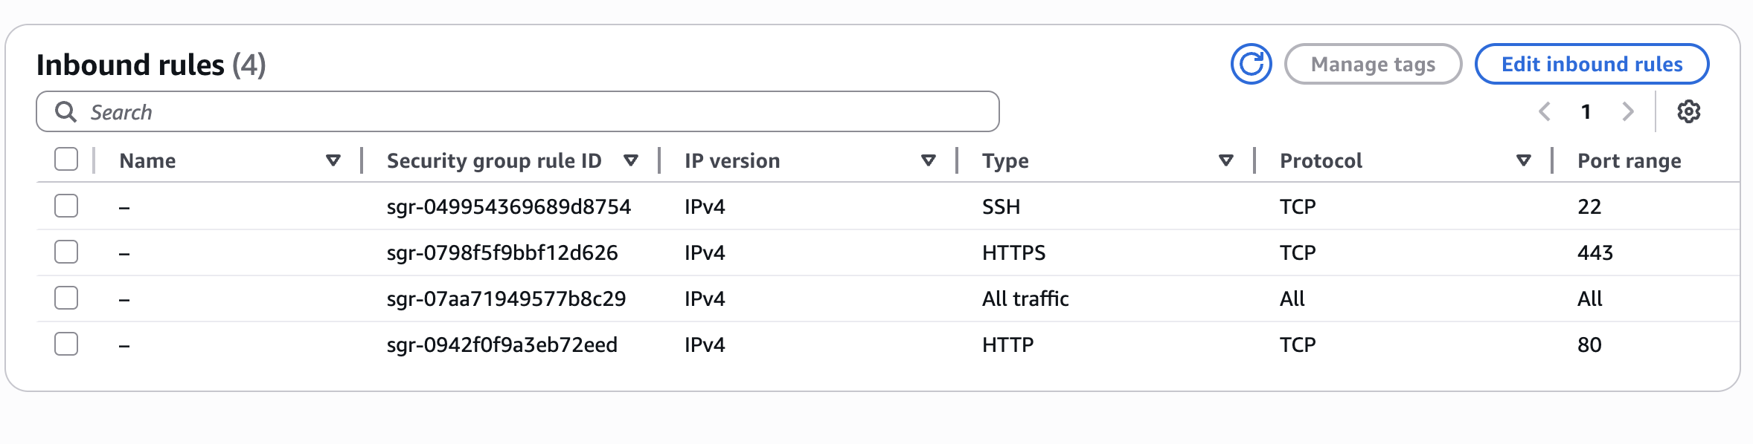

**5.3 Deployment & Nginx Configuration**

Steps performed on the terminal:

1. **Clone Project:** git clone <https://github.com/Student-ITU/Django-Car-Parking-Information-Management-System.git>
2. **Environment Setup:** python3 -m venv env && source env/bin/activate
3. **Install Dependencies:** pip install -r requirements.txt
4. **Nginx Config:** Create a file in /etc/nginx/sites-available/myproject.

**Command used to check Nginx status:**

sudo nginx -t

sudo systemctl restart nginx

**6. Testing and Results**

We verified the deployment using the curl command to ensure the local server is responding correctly. **Command:** curl -I http://127.0.0.1:8000 **Result:** HTTP/1.1 200 OK

**Final Output:** The website is successfully accessible at: **http://35.175.117.155** or **http://ec2-35-175-117-155.compute-1.amazonaws.com/**

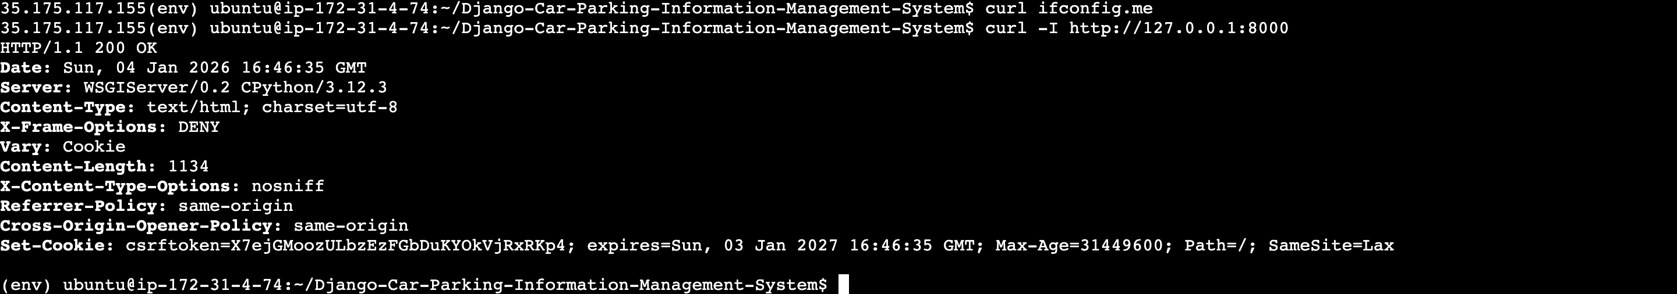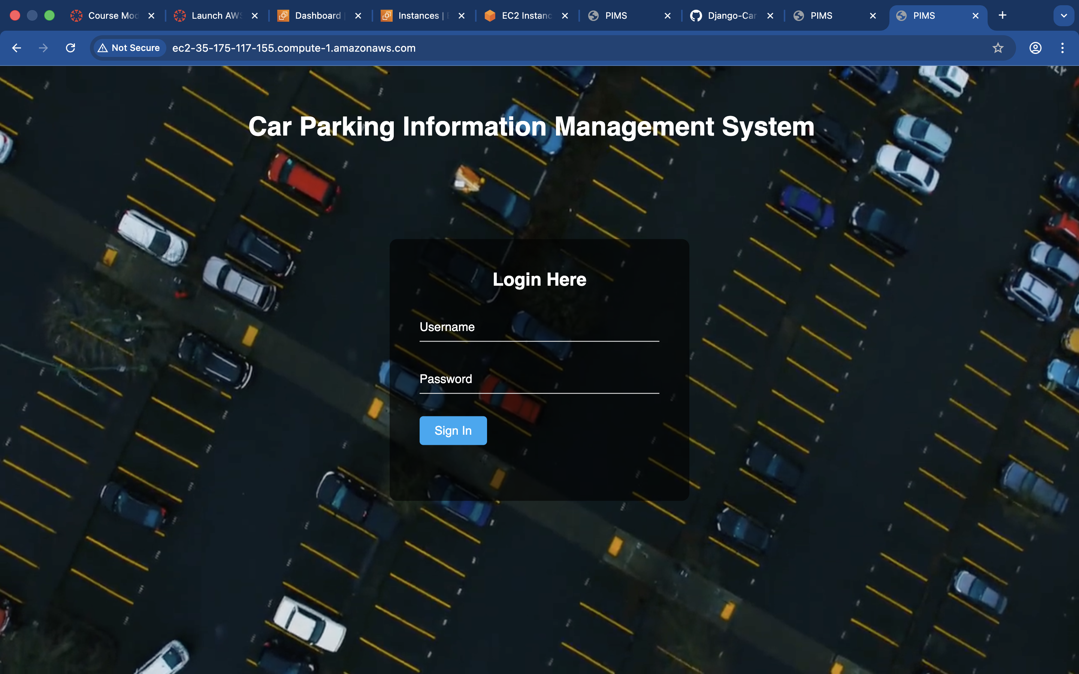

**7. Monitoring & Logging**

For system health, we monitored Nginx error logs and Django process logs. **Command to view logs:**

Bash

sudo tail -f /var/log/nginx/error.log

tail -f nohup.out

**8. Conclusion**

The Car Parking Information Management System was successfully migrated to the AWS Cloud.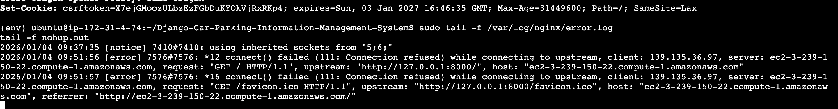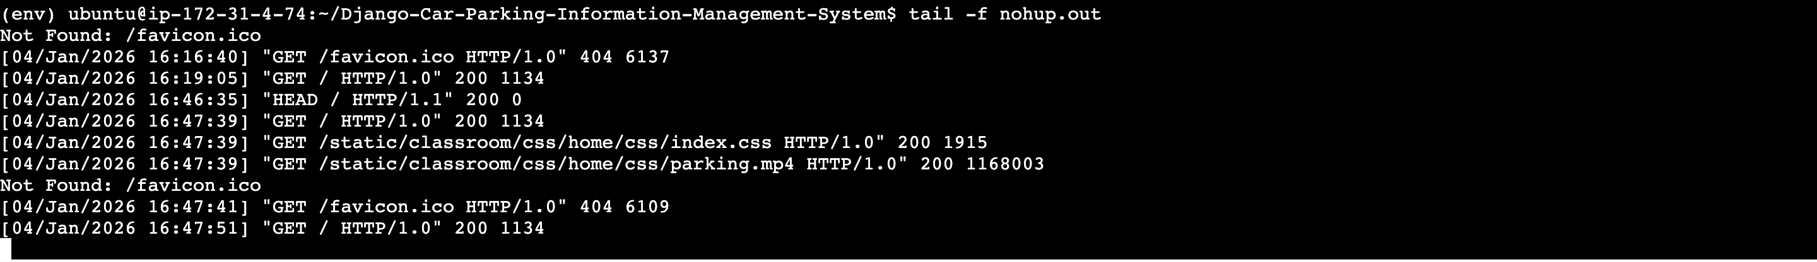 The use of EC2 and Nginx provides a professional-grade hosting environment that is secure and responsive.

**9. References**

1. Amazon Web Services. (2024). *EC2 User Guide for Linux Instances*. Retrieved from <https://docs.aws.amazon.com/ec2/>
2. Django Software Foundation. (2024). *Django Documentation*. Retrieved from <https://docs.djangoproject.com/>
3. Nginx Documentation. (2024). *Beginner’s Guide*. Retrieved from <https://nginx.org/en/docs/beginners_guide.html>